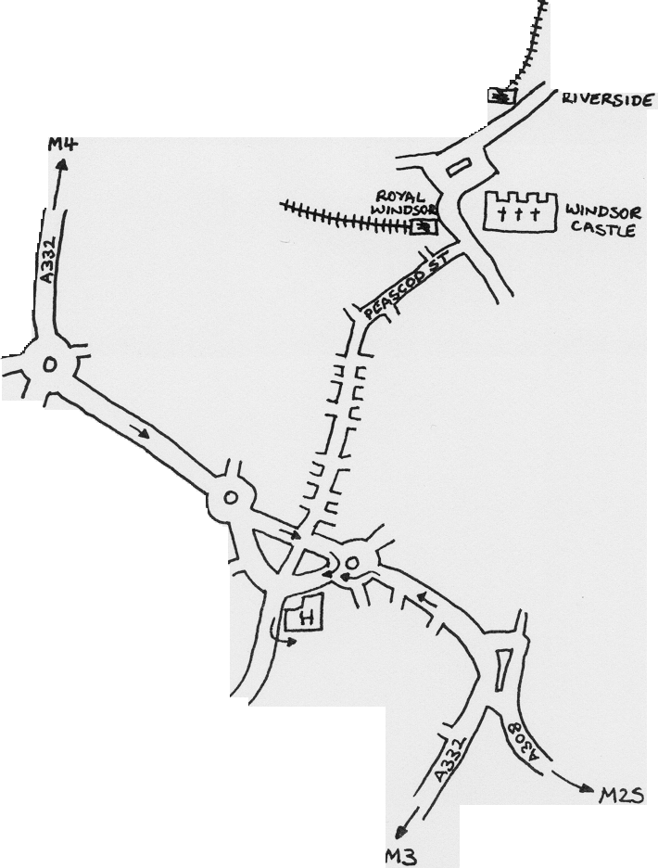

By road: From M4 exit at Junction 6 onto dual carriageway A332. Continue to roundabout and take 2nd exit A308. Straight over next roundabout into one way system. Take right hand lane and turn right just before roundabout. Keep left up the hill and enter by Entrance 1.
From M3 exit at Junction 3 and take A322 (Bagshot). At large roundabout follow signs to Ascot/Windsor A332. Stay on A332 past Ascot and through Windsor Great Park. Follow the road into Windsor keeping in the left hand lane into Osbourne Road. At the small roundabout take the 2nd exit and keep left up the hill and enter by Entrance I.
From M25 exit at Junction 13 (A30). Follow A30 to roundabout at Egham. Take 3rd exit A308 and follow into Windsor. Take 2nd exit at large roundabout into Osbourne Road and follow directions to hospital as for M3.
By rail: Windsor is served by Windsor and Eton Riverside (connections to Waterloo) and Windsor Royal Station (connections to Slough- change there for Paddington, Reading,
Birmingham etc.) It takes about 20 minutes to walk from the stations via Peascod Street.
EAST BERKSHlRE AUDIOLOGY UNIT 01753636222

